ShiJiaZhuang Yitong Filter Machinery Co., Ltd.

Hydrophilic PTFE pleated filter cartridge

Filter area: 0.7㎡
Filter membrane Hydrophilic: PTFE
Guide layer: PP
Inner support、end cap、shell: PP
Seal ring material: Silicone,Viton,EPDM,PTFE
Max.working temperature: ≤80℃
Max. working pressure drop: 0.4Mpa/23℃ / 0.21Mpa/80℃
Sterilization: 121℃/30min steam sterilization

Product Description：

Yitong PTFE cartridge is a hydrophobic filter made of natural hydrophobic PTFE membrane and polypropylene support layers and components.PTFE Membrane Filter Cartridge are retentive that offers superior hydrophobicity and water intrusion resistance compared to PVDF and polypropylene membranes.It is ideal for gas/vent applications and the filtration of aggressive chemicals and solvents, and best fit for critical processes in pharmaceutical industries, chemical plants, beverages & syrups, distilled water plants, etc.

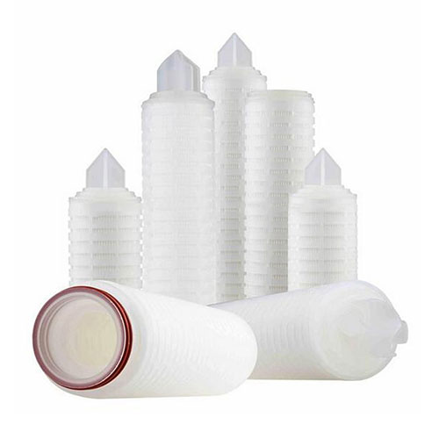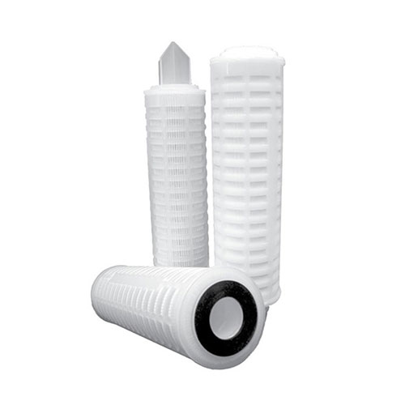

E-mail:manager@yitong-filter.com Mob: +86 180 3376 5689
ShiJiaZhuang Yitong Filter Machinery Co., Ltd.

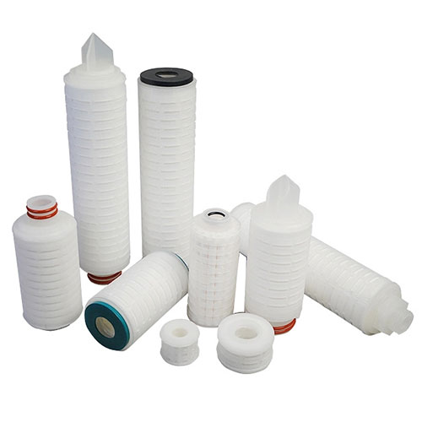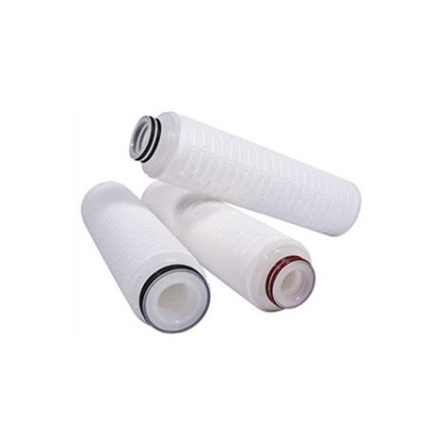

Performance Feature：
1, 100% integrity tested
2, Absolute rated & precisely controlled pore size distribution for
superior & constant bacterial retention.
3, Autoclave or in situ steam sterilization features.
4, Heavy-duty molded cage — high structural strength
5, PTFE membrane has excellent chemical resistance.
6, Low pressure drop and high flow rate

Application：
1 Sterilization filtration in pharmaceutical industry
2 Sterilization filtration of solvents in chemical industry
3 Sterilization filtration of disinfectant and antibiotic

E-mail:manager@yitong-filter.com Mob: +86 180 3376 5689
ShiJiaZhuang Yitong Filter Machinery Co., Ltd.

Technical Parameter：
Cartridge structure | Filter area | 0.7㎡
 | Filter membrane | Hydrophilic PTFE
 | Guide layer | PP
 | Inner support、end cap、shell | PP
 | Seal ring material | Silicone,Viton,EPDM,PTFE
Working situation | Max.working temperature | ≤80℃
 | Max. working pressure drop | 0.4Mpa/23℃
 |  | 0.21Mpa/80℃
 | Sterilization | 121℃/30min steam sterilization

Packing and shipping：
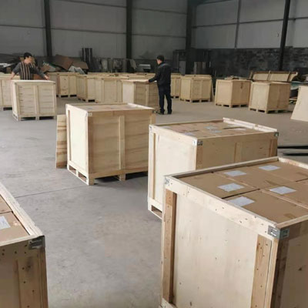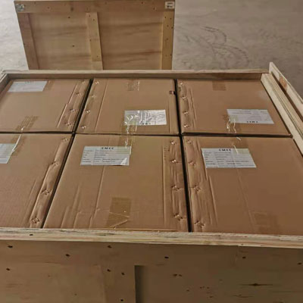

E-mail:manager@yitong-filter.com Mob: +86 180 3376 5689
ShiJiaZhuang Yitong Filter Machinery Co., Ltd.

FAQ：
Q: How can we get the quotation of filter cartridges ?
A: Kindly please let us know the specifications,such as the material,length,micron,adapter,apply in which industry.....
Q: What's the minimal quantity order ?
A: 1 piece
Q:How longabout your delivery ?
A: The order is always arranged in 10 working days as soon as receiving your payment.
Q: Is customized service available ?
A: Yes, we offer customized service
Q: How about payment terms ?
A: We accept L/C, T/T, Escrow, Paypal or as your requirement

E-mail:manager@yitong-filter.com Mob: +86 180 3376 5689

